**St Laurence in Thanet CE Junior Academy**

**Curriculum Statement**

**Religious Education**

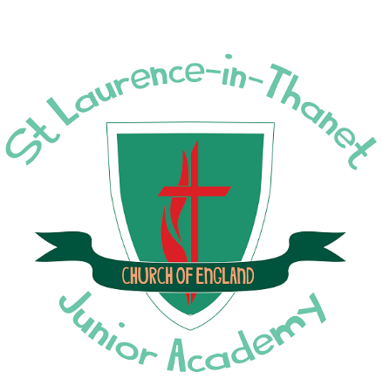

**Believe, Achieve, Aspire!**

**‘Through God all things are possible’ (Matthew 19:26)**

**Contents**

**Page 3**. Statement of Intent

**Page 5.** Spiritual, Moral, Social and Cultural Aspects of the RECurriculum

**Page 6**. Pedagogical Approach—Metacognition

**Page 7**. Pedagogical Approach—Cognitive Load Theory

**Page 8**. Types of Knowledge

**Page 8-9. Religious Education** Subject Leader Action Plan and Monitoring schedule

**Page 11**. Whole School Enrichment Opportunities

**Page 12**. School Long-term Plan

**Pages** **13 – 19** How does the Religious Education scheme of work align with the National Curriculum?

**Page 20 – 21** How is the Religious Education Scheme of work organised?

**Page 22** Whole School Knowledge Progression

**Page 22**. Whole School Skills Progression

**Page 22-27** Vocabulary progression list (Y3 – Y6)

**Page 28 - 30** Inclusion in Religious Education

**Page 31.** Assessment

**Page 32.** Year 3 example Knowledge Organisers

**Page 33.** Year 4 example Knowledge Organisers

**Page 34.** Year 5 example Knowledge Organisers

**Page 35.** Year 6 Whole Year Knowledge Organisers

**Page 36**. Displays

**Religious Education Statement of Intent**

Religious education at St. Laurence will enable every child to flourish and to ‘live life in all its fullness’ (John 10:10). It helps educate for dignity and respect and encourages everyone who is a part of our school to live well together. It is our intention to provide high quality Religious Education. We will teach a full curriculum that prepares our pupils for the opportunities, responsibilities and experiences of life in modern Britain, by providing a safe, happy and supportive learning environment.

Christianity is central to RE here and is studied as a living and diverse faith, focused on the teaching of Jesus and the Church. As an inclusive community, we aim to provide learning opportunities about a range of religions and worldviews, which foster respect for others. Our RE curriculum enables pupils to acquire a rich, deep knowledge and understanding of Christian belief and practice. It engages and challenges children through the exploration of core concepts and key questions. Our RE curriculum follows a spiral progression, building on core concepts. Children will study Christianity in every year group, they will also study Sikhi, Hindu Dharma, Judaism and Islam. Other worldviews and faiths including Humanism are also studied. RE has a high profile within the curriculum and is a priority for senior leaders. The RE curriculum is intrinsic to our Christian vision, enabling all pupils to flourish. RE also provides opportunities to explore British values and spiritual moral social and cultural issues and ideas with an aim to challenge stereotypes, prejudice and extremism.

Pupils develop a wide range of skills including enquiry, analysis, interpretation, evaluation and reflection. We provide a safe space for them to explore their own religious, spiritual and/or philosophical ways of seeing, living and thinking, believing and following the implementation of the RE curriculum, children at St Laurence will be religiously literate and able to hold a balanced and well-informed conversation about religion and beliefs. Pupils will appreciate the intersections between religion and day to day life, including the influence of religions and world views on government, society and culture. Pupils will feel supported in their personal search for meaning. They will be able to reflect on their experiences and the mysteries of life.

**As stated in the Church of England Statement of Entitlement for Religious Education, our aims for all the children in RE are:**

* To know about and understand Christianity as a diverse global living faith through the exploration of core beliefs using an approach that critically engages with Biblical text.
* To gain knowledge and understanding of a range of religions and worldviews appreciating diversity, continuity and change within the religions and worldviews being studied.
* To engage with challenging questions of meaning and purpose raised by human existence and experience.
* To recognise the concept of religion and its continuing influence on Britain’s cultural heritage and in the lives of individuals and societies in different times, cultures and places.
* To explore their own religious, spiritual and philosophical ways of living, believing and thinking.

**Spiritual, Moral, Social and Cultural Aspects of the RE Curriculum**

Through Religious Education children will be able to develop the following: —

**Spiritual:**

Developing deep thinking and questioning the way in which the world works promotes the spiritual growth of our pupils.

We are sensitive to pupils’ individual needs, backgrounds and experience.

We promote a sense of awe and wonder as we consider the world through others’ eyes and the beauty within it.

Offer opportunities for personal reflection and spiritual development.

We help our pupils to express their feelings, thoughts and help them to make choices and decisions.

**Moral:**

Within the classroom, we encourage respect and reward good behaviour. We value listening to others views and opinions on different topics.

We promote discussion about other religious views and beliefs, challenge assumptions, and encourage them to consider aspects of right and wrong in different situations.

We use “big questions” and world events to enable pupils to become more aware of ethical and moral issues within the community and society as a whole.

Through studying others’ responses, we consider consequences of behavior and actions.

**Social:**

In classrooms, we look for opportunities for pupils to use whiteboards to promote self-esteem and build self-confidence.

We encourage collaborative learning in the classroom – in the form of listening and learning from each other and paired discussion / working partners.

We encourage pupils to develop a sense of belonging and identity, acknowledging their rights to individual liberty and developing their understanding of consequences from personal choice.

We seek out events for increased pupil involvement.

Having a better understanding of others and their beliefs allows enables pupils to flourish within their communities as well as individually as citizens in a multicultural, society.

**Cultural:**

We enhance pupil’s awareness and understanding of religious beliefs, teachings, and practices, forms of expression, family life, communities and cultures.

We encourage pupils to respectfully compare religious beliefs, values and traditions to consider how as a world community we are all the same and to celebrate our differences.

We incorporate RE into the school wide Theme Weeks and celebrate the diversity of cultures within our school.

We look to include visitors and visits to enrich our RE curriculum and allow the pupils to explore it through the eyes of others.

We look at religious laws within different religions and relate those to our own laws/ rules that we follow.

**To be most effective, SMSC will be made explicit by staff when delivering the teaching sequence.** [See our SMSC policy here](https://stlaurencejuniors.co.uk/wp-content/uploads/2023/04/SMSC-policy-2023.pdf)

**Pedagogical Approach**

**Metacognition**

*Adapted from: EEF METACOGNITION AND SELF-REGULATED LEARNING—Guidance Report* [EEF_Metacognition_and_self-regulated_learning.pdf (d2tic4wvo1iusb.cloudfront.net)](https://d2tic4wvo1iusb.cloudfront.net/eef-guidance-reports/metacognition/EEF_Metacognition_and_self-regulated_learning.pdf?v=1676624661)

**Teaching Process**

In terms of developing self-regulated learning and metacognition, this means we need to make sure that we don’t give too much information at the same time (when delivering explicit instruction), and do not expect the learner to take on too much challenge when doing guided practice and independent work. The use of structured planning templates, teacher modelling, worked examples, and breaking down activities into steps can help achieve this.

Self-regulation and metacognition strategies work through learners monitoring and evaluating their own learning strategies.

* Explicit teaching
* Teachers modelling
* Opportunities for pupils to reflect on and monitor their strengths and areas of improvement, and plan how to overcome current difficulties.
* Providing enough challenge for learners to develop effective strategies, but not so difficult that they struggle to apply a strategy.

Self-regulated learning can be broken into three essential components that teachers need to know about to help their pupils to develop into successful learners:

Cognition is the mental process involved in knowing, understanding, and learning. By cognitive strategies, we mean skills like memorisation techniques or subject-specific strategies. This is the bread and butter of good teaching; cognitive strategies are fundamental to acquiring knowledge and completing learning tasks.

Metacognition is about the way’s learners monitor and purposefully direct their learning. For example, having decided that a particular cognitive strategy for creating is likely to be successful, a pupil then monitors whether it has indeed been successful and then deliberately changes (or not) their method based on that evidence. By metacognitive strategies, we mean the strategies we use to monitor or control our cognition, such as checking that our technique was accurate or selecting the most appropriate cognitive strategy for the task we are undertaking.

Motivation is about our willingness to engage our metacognitive and cognitive skills and apply them to learning. Motivational strategies will include convincing oneself to undertake a tricky task now—affecting our current well-being—as a way of improving our future well-being in the task tomorrow. Cognition, metacognition, and motivation all interact in complex ways during the learning process. It is impossible to be metacognitive without having different cognitive strategies to hand and possessing the motivation and perseverance to tackle problems and apply these strategies.

**Pedagogical Approach**

**Cognitive Load Theory**

*Adapted from: Cognitive Load Theory: Research that teachers really need to understand*

**Cognitive Load Theory** — aim = to develop instructional techniques that fit within the characteristics of working memory in order to maximise learning.

Based on two principles:

1. There is a limit to how much **new** information the brain can hold. (**Working memory**—processing new information results in ‘cognitive load’ which can affect outcomes.)
2. There is no know limit to how much **stored** information that can be processed at one time. (**Long term memory**—stores information as schemas.

**Explicit instruction** involves teachers clearly showing children what to do, rather than have them construct or discover it for themselves. To lessen cognitive load on working memory. This can be used for new information and learning. Independent learning also needs to be incorporated but with cognitive load managed through guidance, prior information, scaffolds and assistance if needed.

**Long term memory** relies on the formation of schemas where information can be processed automatically with minimal conscious effort. Automaticity happens after extensive practice. Thus reducing working memory load. If working memory is overloaded, there is greater risk that the content will not be understood, be confused and not stored into the long-term memory. Ultimately, learning will be slowed down. Automation of schemas reduces the burden on working memory because when information can be accessed automatically, the working memory is freed up to process new information.

**There are 3 types of Cognitive load**—Intrinsic, Extraneous and Germane

I**ntrinsic** —difficulty of subject matter being learnt, it depends on the complexity of the material and the prior learning—i.e. different people will have different levels of cognitive load depending on their experiences and knowledge

**Extraneous** — how the subject matter is taught—we need to minimise extraneous cognitive load to free up working memory.

**Germane**—the load imposed on the working memory by the process of learning i.e. by transferring information into long-term memory through schema construction.

**Types of Knowledge**

Ofsted RE Research Review (May 2021) - Summary

[Research review series: religious education - GOV.UK (www.gov.uk)](https://www.gov.uk/government/publications/research-review-series-religious-education/research-review-series-religious-education) Full review.

The review recognises that there is no single way of constructing and teaching a high quality RE curriculum.

It identifies three areas of subject-specific knowledge in RE:

1. **Substantive knowledge** about various religious and non-religious traditions;

2. **Disciplinary knowledge** (different ‘ways of knowing’) that enables pupils to understand and use some of the methods and techniques associated with studying religious and non-religious traditions;

3. **Personal knowledge** that enables pupils to better understand and interrogate their own position, presuppositions and values. The report identifies some common features of a high-quality RE curriculum, based on the research reviewed:

• The curriculum should carefully select and cover substantive content and concepts (“collectively enough”) in order to build a schema of knowledge about religious and non-religious traditions, rather than covering excessive amounts of content superficially. The content covered must be sufficient for pupils to grasp a bigger picture about the place of religion and non-religion in the world.

• The RE curriculum must ensure that what is taught and learned in RE is grounded in what is known about religion or non-religion from academic study. This helps prevent pupils from developing misconceptions about religion and non-religion, particular through generalising, stereotyping or essentialising ways of believing, living and thinking.

• Pupils should study certain areas of the RE curriculum in depth and acquire a range of detailed knowledge of different concepts and ideas, which they remember long term. Drawing on this prior knowledge should enable them to consider more complex ideas about religion. Leaders and teachers should select this ‘depth of study’ from contrasting religious and/or non-religious traditions so that pupils avoid developing misrepresentations.

• The curriculum must be well sequenced to ensure that pupils learn the knowledge they need for later topics.

• Teachers and leaders should carefully consider when pupils should relate the content to their own personal knowledge (for example, their own prior assumptions). • Teachers and leaders must ensure that the way in which the curriculum is taught and assessed focuses pupils’ attention squarely on the knowledge they need to learn.

• Leaders must ensure that adequate curriculum time is given to RE, so that leaders can deliver an ambitious curriculum [the Dearing Report sets the expectation at 5% of curriculum time dedicated specifically to RE, not to an amalgamation of RE and other curriculum subjects, such as Humanities, PSHE, Citizenship, etc.]

• Leaders must ensure that there is sufficient training and professional development so that teachers have appropriate subject professional knowledge.

**Religious Education - Key areas for development**

|  |  |
| --- | --- |
| **Targets** | **What success will look like** |
| Strengthen RE teaching and learning across the school  Ensure staff feel confident to deliver the RE curriculum SIAMS 2), 3) | Progression of skills is evident in books and planning.  Stakeholders feels more confident and can discuss the skills and progression of the subject.  TAs generally more confident.  Teachers will have completed their year group UC training and the world faith unit training for their year group. TAs invited to do the same |
| Continue to embed the Vocabulary project SIAMS 3) Teachers started this in T5/6 last year. Using ‘vital vocab’ slides at the beginning of the lessons to go through key unit vocabulary.  This vocabulary is also on the new fronts covers for each unit so the children can refer back to the words along with the definition.  Vocab should be displayed on the working wall. | Children are becoming more religiously literate.  Can talk about their key vocab for the unit and even if they can’t remember the words they can show me where they would find it in their books/on their working walls.  Staff should be able to do the same. |
| To support Courageous Advocacy throughout school life.  SIAMS 2), 3) Children will learn about the important work of the societies and charities. They will be engaged in activities including fund raising, awareness raising and direct action, understanding how they can have an impact on society. | Children will have a passion to make a difference and will raise their concerns about the issues they are interested. House group displays, whole school and house theme days. General fundraising activities.  **Harvest Festival collection was for Salvation Army in Ramsgate. MAF project started Dec 23.**  **Prayer chains for Advent Peace – Dec 23** **, Children in Need Nov 23**, Red Nose Day March 24. World Diabetes Day Nov 23 Children in Need day Nov 2024, Red Nose Day March 2025, Hello Yellow October 24 |
| To deepen subject knowledge of World Faiths.SIAMS 2), 3 | Staff will feel more confident to deliver WF units. Children have a wider knowledge of different faiths and can make links (i.e. different festivals of light) Visits to Canterbury Cathedral (Y4 and 5) and Ramsgate Synagogue (Y6) |

|  |  |  |
| --- | --- | --- |
| **Term** | **Monitoring** | **Impact questions** |
| Term 1 & 2 | RE books  Link Governor visit | Are all the required elements in all RE books consistently?  Is there good use of ‘I wonder’ questions in all books?  Are children able to respond to the IW questions to demonstrate GDS?  Is the presentation of a high standard? |
| Term 3 & 4 | RE lesson observations | Are the Golden Threads elements weaved through lessons? Visible on slides?  Are retrieval activities planned into each lesson?  Are opportunities for challenge and I wonder questions used? |
| Term 6 | Pupil voice | Do children enjoy RE?  What can they remember about what they have learnt?  Can they make connections with the Golden Threads and across faiths? |

**Whole School Cultural Capital /Enrichment Opportunities**

|  |  |  |
| --- | --- | --- |
| **Whole School Cultural Capital / Enrichment Opportunities (minimum of 3 a year)** | | |
| **Term** | **Event** | **RE link** |
| 1 | Church visits | Harvest Festival, Christmas Service, Easter service  Remembrance Service, Year 6 Canterbury Cathedral Day, Year 6 Leavers Service  Year 5 children take part in ‘Christmas Unwrapped’ with ACTS (Active Christiantiy in Thanet Schools) to unpack the meaning of the Christmas story. |
| 2 | Christmas Around the World Service in Church | Children appreciate how Christians celebrate Christmas in different ways around the world but that there are also similarities |
| 3 | Sikhi workshop | Sikhi unit -Yr 3 All day workshop in school 2023 |
| 4 | Easter play  Synagogue Visit Y6 Yr 4/5 Canterbury Cathedral | Children appreciate how Christians celebrate Easter in different ways around the world but that there are also similarities  Year 5 children take part in ‘Easter Cracked’ with ACTS (Active Christiantiy in Thanet Schools) to unpack the meaning of the Easter story.  Children visit a local Synagogue to deepen learning about Judaism |
| 5 |  |  |
| 6 | Church Visits | Year 6 children take part in transition work with ACTS (Active Christianity in Thanet Schools) |

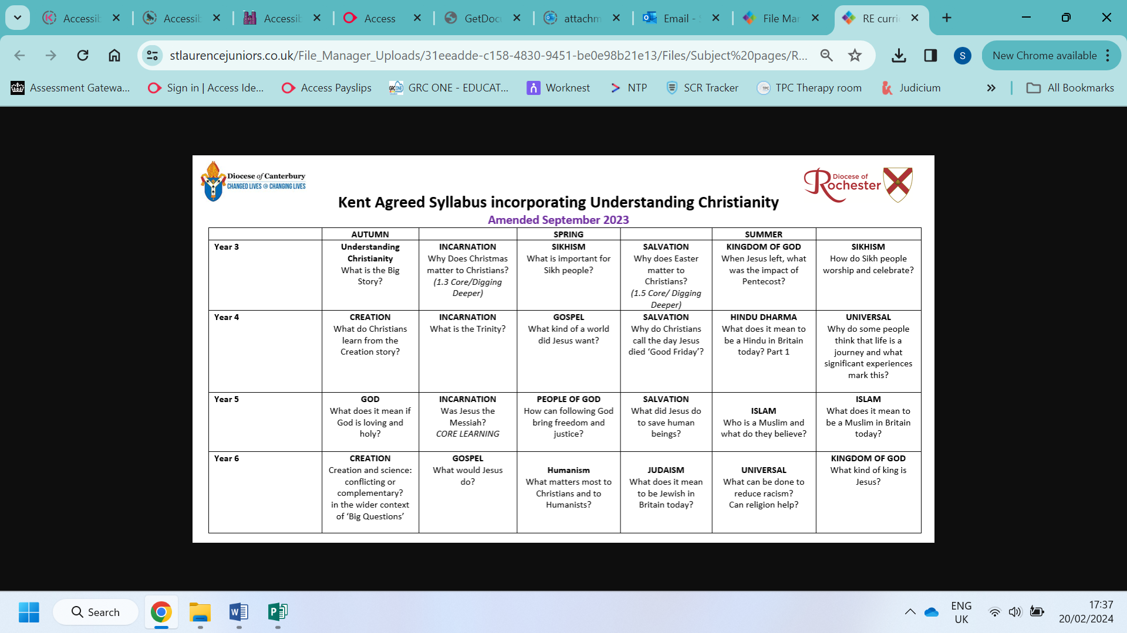

**RE does not have a National Curriculum so we follow the Understanding Christianity scheme and combine this with the Kent Agreed Syllabus**

|  |  |
| --- | --- |
| NC - KS2 | **God**  Christians believe God is omnipotent, omniscient and eternal, and that this means God is worth worshipping. • Christians believe God is both holy and loving, and Christians have to balance ideas of God being angered by sin and injustice (see Fall) but also being loving, forgiving, and full of grace. • Christians believe God loves people so much that Jesus was born, lived, was crucified and rose again to show God’s love. • Christians do not all agree about what God is like, but try to follow his path, as they see it in the Bible or through Church teaching. • Christians believe getting to know God is like getting to know a person rather than learning information.  **Creation**  God the Creator cares for the creation, including human beings.  • As human beings are part of God’s good creation, they do best when they listen to God.  • The Bible tells a story (in Genesis 3) about how humans spoiled their friendship with God  (sometimes called ‘the Fall’).  • This means that humans cannot get close to God without God’s help.  • The Bible shows that God wants to help people to be close to him – he keeps his relationship with them, gives them guidelines on good ways to live (such as the Ten Commandments), and offers forgiveness even when they keep on falling short.  • Christians show that they want to be close to God too, through obedience and worship, which includes saying sorry for falling short.  • There is much debate and some controversy around the relationship between the accounts of creation in Genesis and contemporary scientific accounts.  • These debates and controversies relate to the purpose and interpretation of the texts: for example, does reading Genesis as a poetic account conflict with scientific accounts?  • There are many scientists through history and now who are Christians.  • The discoveries of science make Christians wonder even more  **People of God**  The Old Testament tells the story of a particular group of people, the children of Israel – the People of God – and their relationship with God.  • The People of God try to live in the way God wants, following his commands and worshipping him.  • They believe he promises to stay with them, and Bible stories show how God keeps his promises.  • The Old Testament narrative explains that the People of God are meant to show the benefits  of having a relationship with God, and to attract all other nations to worshipping God.  • Christians believe that, through Jesus, all people can become the People of God.  • The Old Testament pieces together the story of the People of God. As their circumstances change (for example, from being nomads (Abraham, Jacob) to being city dwellers (David)), they have to learn new ways of following God.  • The story of Moses and the Exodus shows how God rescued his people from slavery in Egypt; Christians see this story as looking forward to how Jesus’ death and resurrection also rescue people from slavery to sin.  • Christians apply this idea to living today by trying to serve God and to bring freedom to others, for example by loving others, caring for them, bringing health, food, justice, and telling the story of Jesus.  • Christians see the Christian Church as part of the ongoing story of the People of God, and try to live in a way that attracts others to God, for example as salt and light in the world.  **Incarnation**  Christians believe Jesus is one of the three persons of the Trinity: God the Father, God the Son and God the Holy Spirit.  • Christians believe the Father creates; he sends the Son who saves his people; the Son sends the Holy Spirit to his followers.  • Christians worship God as Trinity. It is a huge idea to grasp, and artists have created art to help to express this belief.  • Christians believe the Holy Spirit is God’s power at work in the world and in their lives today, enabling them to follow Jesus.  • Jesus was Jewish.  • Christians believe Jesus is God in the flesh.  • They believe that his birth, life, death and resurrection were part of a longer plan by God to restore the relationship between humans and God.  • The Old Testament talks about a ‘rescuer’ or ‘anointed one’ — a messiah. Some texts talk about what this ‘messiah’ would be like.  • Christians believe that Jesus fulfilled these expectations, and that he is the Messiah. (Jewish people do not think Jesus is the Messiah.)  • Christians see Jesus as their Saviour.  **Gospel**  Christians believe Jesus challenges everyone about how to live – he sets the example for loving God and your neighbour, putting others first.  • Christians believe Jesus challenges people who pretend to be good (hypocrisy), and shows love and forgiveness to unlikely people.  • Christians believe Jesus’ life shows what it means to love God (his Father) and love your neighbour.  • Christians try to be like Jesus – they want to know him better and better.  • Christians try to put his teaching and example into practice in lots of ways, from church worship  to social justice.  Christians believe the good news is not just about setting an example for good behaviour and challenging bad behaviour: it is that Jesus offers a way to heal the damage done by human sin.  • Christians see that Jesus’ teachings and example cut across expectations — the Sermon on the Mount is an example of this, where  Jesus’ values favour serving the weak and vulnerable, not making people comfortable.  • Christians believe that Jesus’ good news transforms lives now, but also points towards a restored, transformed life in the future (see Salvation and Kingdom of God).  • Christians believe that they should bring this good news to life in the world in different ways, within their church family, in  their personal lives, with family, with their neighbours, in the local, national and global community.  **Salvation**  • Christians see Holy Week as the culmination of Jesus’ earthly life, leading to his death and resurrection.  • The various events of Holy Week, such as the Last Supper, were important in showing the disciples what Jesus came to earth to do.  • Christians today trust that Jesus really did rise from the dead, and so is still alive today.  • Christians remember and celebrate Jesus’ last week, death and resurrection.  Christians read the ‘big story’ of the Bible as pointing out the need for God to save people. This salvation includes the ongoing  restoration of humans’ relationship with God.  • The Gospels give accounts of Jesus’ death and resurrection.  • The New Testament says that Jesus’ death was somehow ‘for us’.  • Christians interpret this in a variety of ways: for example, as a sacrifice for sin; as a victory over sin, death and the Devil; paying the  punishment as a substitute for everyone’s sins; rescuing the lost and leading them to God; leading from darkness to light, from slavery to freedom.  • Christians remember Jesus’ sacrifice through the service of Holy Communion (also called the Lord’s Supper, the Eucharist or the  Mass).  • Belief in Jesus’ resurrection confirms to Christians that Jesus is the incarnate Son of God, but also that death is not the end.  • This belief gives Christians hope for life with God, starting now and continuing in a new life (Heaven).  • Christians believe that Jesus calls them to sacrifice their own needs to the needs of others, and some are prepared to die for others and for their faith.  **Kingdom of God**  • Christians believe that Jesus inaugurated the ‘Kingdom of God’ – i.e. Jesus’ whole life was a demonstration of his belief that God is king, not just in heaven but here and now (‘Your kingdom come, your will be done on earth as it is in heaven’).  • Christians believe Jesus is still alive, and rules in their hearts and lives through the Holy Spirit, if they let him.  • Christians believe that after Jesus returned to be with God the Father, he sent the Holy Spirit at Pentecost to help the Church to make Jesus’ invisible kingdom visible by living lives that reflect the love of God.  • Christians celebrate Pentecost as the beginning of the Church.  • Staying connected to Jesus means that the fruit of the Spirit can grow in the lives of Christians.  • Jesus told many parables about the Kingdom of God. These suggest that God’s rule has begun, through the life, teaching and example of Jesus, and subsequently through the lives of Christians who live in obedience to God.  • The parables suggest that there will be a future Kingdom, where God’s reign will be complete.  • The Kingdom is compared to a feast where all are invited to join in. Not everyone chooses to do so.  • Many Christians try to extend the Kingdom of God by challenging unjust social structures in their locality and in the world.  **Racism**  •Discover and think about the meanings of some key ideas about racism and religion by studying some people who have given their lives to reducing prejudice and hatred.  •Learn in depth and detail about the statues of Colston and Wesley in Bristol.  • Consider how music, film, prayer, art and other forms of expression have been used in struggles against racism.  • Enable pupils to think for themselves about the ways that scriptures encourage religious people to treat all humans with dignity, respect, equity or love – and consider reasons why this does not always happen.  • Learn that early Christian traditions include important stories about human unity, even though the Christian church has sometimes been complicit in racism.  • Learn that Prophet Muhammad taught his followers to set racial difference aside.  • Ask good questions about racism and equality, discussing how religion could make more positive contributions to justice.  • Consider some questions, such as: can prayer help reduce racism? Does God care about racism? Why are religious people sometimes racist even though they preach love for all? Is it only religious people who fail to live up to their ideals?  • Create a work of art and commentary on it, expressing pupils’ reactions to the idea that ‘we have far more in common than keeps us apart’.  • Pupils weigh up their own learning in relation to their own ideas about equity, justice and race..  Why do some people think life is a journey?  • Explore and use the religious metaphor of life as a journey. What are the significant milestones on this journey? What other metaphors could be used for life?  • Consider the value and meaning of ceremonies which mark milestones in life, particularly those associated with growing up and taking responsibility within a faith community: in Christianity, confirmation and ‘believers’ baptism’ or adult baptism, first communion and confession (Roman Catholic); sacred thread ceremony in Hinduism; bar/bat mitzvah/chayil in Judaism. Explore the symbols and rituals used, and the promises made. Do non-religious people e.g. Humanists mark these moments?  • What meaning do these ceremonies have to the individual, their family and their communities?  • Rank, sort and order some different commitments held by believers in different religions – and by the pupils themselves.  • Think about the symbolism, meaning and value of ceremonies that mark the commitment of a loving relationship between two people: compare marriage ceremonies and commitments in two religious traditions. What promises are made? Why are they important? Compare with non-religious ceremonies.  • Explore some basic ideas about what Christians, Hindus and Jewish people believe about life after death; how do they mark the end of life?  • Work with the metaphor of life as a journey: what might be the signposts, guidebooks, stopping points or traffic jams? Does religious or spiritual teaching help believers to move on in life’s journey?  • Create a ‘map of life’ for a Hindu, Jewish or Christian person, showing what these religions offer to guide people through life’s journey. Can anyone learn from another person’s ‘map of life’? Is a religion like a ‘map of life’?  • Reflect on their own ideas about community, belonging and belief.  **Sikhi**  • Sikhs can worship at any time or day, at home or in the Gurdwara.  • Sikhs are expected to pray three times a day and mediate and recite words from the holy scriptures  • Sikh people respect and regard The Guru Granth Sahib as a living Guru.  • The Gurdwara is place that is welcome and open to everyone and is known as the ‘doorway to the house of God’  • All Sikhs are encouraged by their Guru (Guru Granth Sahib) to perform Seva or Selfless Service.  • Vaisakhi is the biggest and most important Sikh festival, where they remember the founding of the Khalsa and the Sikh New Year.  Sikhs believe that there is only one God, who they have several names for. (Waheguru)  • Sikhs try to put the teachings and examples of the 10 gurus into daily practice by living a good life, treating everyone equally and sharing all they have.  • It is important for Sikh’s to belong to a community of believers called the Khalsa.  • Khalsa Sikhs wear 5 articles of faith which reminds them of their faith and duty as a Sikh.  **Hindu Dharma**  This plan has selected the following content to exemplify the learning outcomes.  • Find out about how Hindus show their faith within their families.  • Learn that ‘Hinduism’ is incredibly diverse as a whole way of life rather than a set of beliefs.  • Find out about the objects involved in puja at home and at the mandir; murtis, family shrine, statues and pictures of deities, puja tray including incense, fruit, bells, flowers, candles;  • Learn about an important sacred text; the Bhagavad Gita  • Learn about Hindu religious ritual; the OM, blessing food, the aarti ceremony, singing hymns (bhajans).  • Explore Hindu ideas about the four aims of life (punusharthas) dharma: religious or moral duty; artha: economic development, providing for family and society by honest means; kama: regulated enjoyment of the pleasures and beauty of life; moksha: liberation from the cycle of birth and rebirth; reincarnation.  • Explore Hindu ideas of karma – how actions bring good or bad karma. Find out how and why ‘snakes and ladders’ links with Hindu ideas of karma.  • Explore what Hindus do to show their tradition within their faith  • Find out about the deities and how they help Hindus achieve moral aims  • Find out about moral aims for others and moral aims for self; karma and dharma • See what Hindu moral teachings in action look like. Mahatma Gandhi, Pandurang Shastri Athavale  **Islam**  • Explore the practice, meaning and significance of the Five Pillars of Islam as an expression of ibadah (worship and belief in action). Shahadah (belief in one God and his Prophet); salat (daily prayer); sawm (fasting); zakat (alms giving); hajj (pilgrimage). How do these affect the lives of Muslims, moment by moment, daily, annually, in a lifetime?  • Think about and discuss the value and challenge for Muslims of following the Five Pillars, and how they might make a difference to individual Muslims and to the Muslim community (Ummah). Investigate how they are practised by Muslims in Britain today. Consider what beliefs, practices and values are significant in pupils’ lives.  • Consider the importance of the Holy Qur’an for Muslims: how it was revealed to the Prophet Muhammad, how it is used, treated, learnt. Share examples of stories and teaching, e.g. Surah 1, Al-Fatihah (The Opening); Surah 17, the Prophet’s Night Journey. Find out about people who memorise the Qur’an and why (hafiz, hafiza).  • Find out about the difference between the authority of the Qur’an and other forms of guidance for Muslims: Sunnah (practices, customs and traditions of the Prophet Muhammad); Hadith (sayings and actions of the Prophet Muhammad).  • Reflect on what forms of guidance pupils turn to when they need guidance or advice, and examine ways in which these are different from the Qur’an for Muslims.  • Investigate the design and purpose of a mosque/masjid and explain how and why the architecture and activities, such as preparing for prayer, reflect Muslim beliefs.  **Judaism**  • Jewish people believe in one God and that the Shema prayer gives details of the ways in which Jewish people should live, worship God and pray.  • Jewish people follow the teachings of the Torah. It teaches them how to pray, worship and how to treat others.  • Yom Kippur and Rosh Hashanah are the holiest days for Jewish people, where they ask for forgiveness at the start of their new year.  • Jewish people celebrate Pesach each year to remember God’s rescue and faithfulness to the Israelites.  • Tzedakah means ‘healing the world’ which is an important value in the Jewish faith as they are all challenged to care for the world that God gave them and the people who live upon it. |

**How is the RE Scheme of work organised?**

The core concepts, including other world faiths, fit into a spiral curriculum where concepts are re-visited and explored in more depth as pupils move through the school. These are explored through key questions, however, and so are not applied exclusively – links and connections will be made between concepts during units.

** (from Understanding Christianity)**  

The Understanding Christianity scheme, uses carefully planned progressive steps to teach children key concepts. Throughout the school, these concepts are taught using 3 key steps.

The scheme uses 8 core concepts, which go through the ‘Big Story’ of the Bible. Not all concepts are taught to each age phase but as the children’s knowledge grows and develops, more concepts are taught. Concepts are taught with an over-arching ‘key question’ for the entire unit and concepts are re-visited regularly and explored in more depth each time allowing links and connections to be made between concepts during units.

In RE, we approach the teaching of faiths (including other world faiths) through 3 different disciplines: theology, philosophy and social and human sciences. This ensures children have a depth of understanding including the theological concept, how faith impacts on individuals lives and what this looks like in their community.

Children can then make comparisons between faiths and their own experiences.

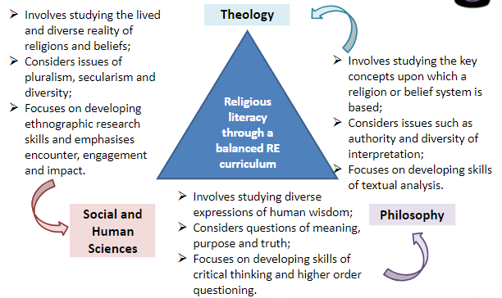

**RE – Whole school Knowledge and Skills Progression**

**Skills Progression:**

|  |  |  |  |
| --- | --- | --- | --- |
|  | **Emerging** | **Expected** | **Exceeding** |
| **Lower Key stage 2** | Identify beliefs  Retell and suggest the meanings of stories  Recall and name  Recognise | Describe some ways  Ask questions and suggest some of their own responses  Suggest why  Identify how  Make connections between stories  Give examples of how and suggest reasons why  Discuss their own and others ideas  Explore and suggest ideas  Link up some questions and answers | Identify some similarities and differences  Discuss and present their own ideas about why  Express their own understanding  Present their own ideas about attitudes  Make between key concepts and the big story of the Bible  Consider and evaluate  Suggest how and why  Express ideas |
| **Upper Key stage 2** | Define the term  Give two reasons  Recall  Find out  Respond with their own ideas  Identify the  Describe | Outline clearly  Give examples of ways  Express thoughtfully  Present different views  Express their own understanding  Explain the impact  Express ideas  Explain some similarities and differences between  Explain some reasons why  Make connections between  Suggest some reasons why  Describe and reflect | Explain how xxx disagree and interpret things differently  Explain the links between … giving reasons why  Enquire into … using evidence and examples  Interpret a range of …  Investigate and explain … expressing their own ideas  Examine the title question from different perspectives including their own.  Apply ideas ..  Consider and evaluate |

**Religious Education–** V**ocabulary progression list (Y3 – Y6)**

**Understanding Christianity**

|  |  |  |
| --- | --- | --- |
| **Area** | **Year 3 and 4** | **Year 5 and 6** |
| **God** |  | |  | | --- | | **Omnipotent** | | **Eternal** | | **Omniscient** | | **Holy** | | **Loving** | | **Forgiving** | | **Sin** | | **Grace** | | **Injustice** | | **Confessional** | | **Reconciliation** | | **Holiness** | | **Psalms** | |  | |
| **Creation** | |  | | --- | | **Timeline** | | **Responsible** | | **Design** | | **Garden of Eden** | | **Temptation** | | **Human Nature** | | **Forgiveness** | | **Punishment** | | **Sin** | | **Commandments** | | |  | | --- | | **Contemporary** | | **Scientific** | | **Controversy** | | **Conflict** | | **Wonder** | | **Majesty** | | **Power** | | **Interpretations** | | **Cosmology** | | **Evolution** | |
| **People of God** | |  | | --- | | **Promises** | | **Agreements** | | **Covenant** | | **Vows** | | **Faith** | | **Trust** | | |  | | --- | | **Freedom** | | **Justice** | | **Theological** | | **Exodus** | | **Slavery** | | **Obedience** | | **Salvation** | | **Commandments** | | **Covenant** | | **Christian Church** | | **Injustice** | | **Mission** | | **Nomads** | |  | |
| **Incarnation** | |  | | --- | | **Gratitude** | | **incarnate** | | **incarnation** | | **saviour** | | **Trinity** | | **Father** | | **Son** | | **Holy Spirit** | |  | | |  | | --- | | **Messiah** | | **Prophecy** | | **Trinity** | | **Incarnation** | | **Saviour** | | **Anointed** | | **Transformation** | | **Transfiguration** | | **Revolution** | |
| **Gospel** | |  | | --- | | **Neighbour** | | **Disciple** | | **Clergy** | | **Teachings** | | **Parable** | | **Hidden Meaning** | | **Love** | | **Hypocrisy** | | **Social Justice** | |  | | |  | | --- | | **National** | | **Global** | | **Sermon** | | **Commandments** | | **Miracle** | | **Transformation** | | **Sacrament** | | **Discipleship** | |
| **Salvation** | |  | | --- | | **Creation** | | **Fall** | | **Maundy Thursday** | | **Last Supper** | | **Holy Communion** | | **Passover** | | **Death** | | **Crucifixion** | | **Resurrection** | | **Ritual** | | **Betrayal** | | **Trust** | | |  | | --- | | **Pesach** | | **Sacrifice** | | **Eucharist** | | **Mass** | | **Victory** | | **Restoration** | | **Epitaph** | | **Memorial** | |
| **Kingdom of God** | |  | | --- | | **Pentecost** | | **Holy Spirit** | | **Kingdom** | | **Anxieties** | | **Worries** | | **Bereaved** | | **King** | | **Comforter** | | **Fruits of the Spirit** | | **Virtues** | | **Parish** | | **Fellowship** | | **Narrative** | | **Letter (as text)** | | **Inaugurated** | | **Invisible** | | **Body of Christ** | | **Father** | | **Son** | | **Unjust** |

**World Faiths**

|  |  |  |
| --- | --- | --- |
| **Area** | **Year 3 and 4** | **Year 5 and 6** |
| **Islam** |  | |  | | --- | | **Shahadah** | | **Salah** | | **Zakat** | | **Sawm** | | **Hajj** | | **Ramadan** | | **ummah** | | **Makkah** | |
| **Hindu Dharma** | |  | | --- | | **dharma** | | **ashrama dharma** | | **atman** | | **artha** | | **kama** | | **karma** | | **moksha** | | **Samsara** | | **Mandir** | | **shrine** | | **deity** | | **murti** | | **puja** | | **Sewa** | | **Aum (Om)** | | **Aarti** | | **Brahman** | | **Vishnu** | | **Shiva** | | **Diwali** | | **deity** | |  |
| **Judaism** |  | |  | | --- | | **Talmud** | | **Rosh Hashanah** | | **Yom Kippur** | | **Pesach** | | **Seder** | | **Fast** | | **Shofar** | | **Nomads** | |
| **Sikhi** | |  | | --- | | **Sikhi** | | **Guru Nanak** | | **Guru Gobind Singh** | | **Guru** | | **Guru Granth Sahib** | | **Gurdwara** | | **Gurmukh** | | **Mool Mantra** | | **Amrit** | | **Khalsa** | | **5 Ks** | | **Seva** | | **Langar** | | **Waheguru** | | **Khanda** | | **Karma** | | **Paat** | | **Kirtan** | | **Vaisakhi** | |  |
| **World Faith Stories** |  |  |

**Inclusion in RE**

At St Laurence CE Junior Academy, we strongly believe in inclusive education to ensure all pupils engage to the best of their ability.

In **RE** this will look like:

|  |  |
| --- | --- |
| **Inclusion in RE** | RE has the potential to greatly enhance the learning experience of children with special educational needs. It enables them to grasp and comprehend complex religious and life-related concepts that may not always be effectively expressed in their written work. The RE Agreed Syllabus promotes inclusive education. RE is a core subject taught to all pupils with a significant positive impact on the mentioned concerns. Teachers of RE acknowledge that all pupils have unique needs based on their experiences, and effective teaching addresses these individual needs. |
| **Positive role of RE** | There is strong evidence that RE positively contributes to the academic achievement of pupils nationally and locally. OFSTED reports highlight RE as the most effective subject in fostering pupils' spiritual, moral, social, and cultural development. This is particularly important for affirming the educational progress of pupils from diverse backgrounds. RE addresses issues that promote the well-being of all pupils and boosts the self-esteem of specific groups. It emphasises equality of opportunity, the intrinsic value of all pupils, and their rights and responsibilities. RE cultivates the values and attitudes necessary for thriving in a diverse society that recognises and values both similarities and differences for the collective benefit. |
| **Building on pupil’s interests and experiences** | Some children with special educational needs have a heightened awareness of people's feelings and a curiosity about their actions. This can lead to an interest in the impact of religious beliefs on individuals and how they practice their faith. For example, instead of testing comprehension of the Exodus story, a teacher could encourage students to draw their own picture of a promised land, allowing them to express their personal vision and understanding. |
| **Removing barriers** | To ensure inclusivity in religious education lessons, teachers should proactively anticipate potential barriers that may hinder the participation and learning of students with specific SEN and/or disabilities. Consequently, during the planning stage, it is crucial to consider strategies that minimise or eliminate these barriers, enabling all students to fully engage and learn. In certain activities, students with SEN and/or disabilities can actively participate alongside their peers without any modifications. However, in other instances, scaffolding may be necessary to ensure the inclusion of all students. Some activities may require the provision of parallel tasks for students with SEN and/or disabilities, allowing them to pursue the same lesson objectives as their peers but through a different approach. |

**Teacher responsibilities as laid out in the SEND Code of Practice: ​**

*“6.12 All pupils should have access to a broad and balanced curriculum. The National Curriculum Inclusion Statement states that teachers should set high expectations for every pupil, whatever their prior attainment. Teachers should use appropriate assessment to set targets which are deliberately ambitious. Potential areas of difficulty should be identified and addressed at the outset. Lessons should be planned to address potential areas of difficulty and to remove barriers to pupil achievement. In many cases, such planning will mean that pupils with SEN and disabilities will be able to study the full national curriculum.​”*

|  |  |
| --- | --- |
| **How this subject can support a pupil with a specific SEND – with reference to the Kent Mainstream Core Standards** | |
| **Communication and Interaction** (ASD, Articulation, fluency, willingness to communicate, vocabulary, understanding and language structure. Additional languages spoken, social skills and interaction) | |
| **Subject specific Support for this aspect of SEND**  Minimal language load involved in achieving a successful outcome  A multisensory approach – environmental modifications.  AAC systems – visual aids, communication boards, technology-based tools.  Social skills support – maintains conversations, non-verbal cues, understanding social norms. | **Strategies to overcome potential barriers arising from this subject**  “Now (you are doing this) and Next (you are going to be doing that)” boards and sequence strips  Use the learner’s name to gain their attention before giving instructions  Keep instructions simple  Awareness of own tone of voice (calm and not too loud)  Pre-teach topic vocabulary  Encourage ‘thinking time’.  Sensory considerations  Family involvement  Encourage peer support.  Foster an inclusive and accepting environment.  Alternative communication methods – sign language, Widgit, Communicate in Print, AAC devices.  Patience and wait time. |
| **Cognition & Learning** ( Dyslexia, approaches and attitudes to learning, reasoning, organisational skills, problem solving skills and independent learning) | |
| **Subject specific Support for this aspect of SEND**  Minimal requirement for Reading / Writing  Reduced memory load  Multi sensory, explicit, differentiated instructions – accommodate diverse learning styles.  Scaffolding – break down complex tasks, information into smaller sections, visual organisers, checklists.  Metacognitive strategies – self-monitoring/regulation, reflective thinking. | **Strategies to overcome potential barriers arising from this subject**  Use simple language and provide visual supports.  Break information down into smaller, manageable chunks to reduce cognitive overload.  Assistive technology – Software that can support reading, writing, memory and organisational skills.  Accommodations and modifications – extra time for tasks, allowing use of assistive devices or tools, alternative fonts, accessible Bibles.  Using visual cues, checklists.  Provide clearly labelled resources.  Consistent routines to reduce confusion and enhance focus.  Regular reviews and reinforcement of previous learning – strategies such as quizzes, games, interactive activities.  Metacognitive strategies – encourage reflective learning, provide guidance in self monitoring, evaluation, identify effective strategies. |

|  |  |
| --- | --- |
| **Social Emotional and Mental Health** (ADHD, ADD, Self-image, confidence, anxiety, motivational factors, engagement with learning, classroom / playground behaviour) | |
| **Subject specific Support for this aspect of SEND**  **Scaffolded instruction – accommodate diverse learning needs and preferences.**  **Provide different options for expressing understanding - written responses, verbal presentations, artistic creations, group discussions.**  **Positive and inclusive environment.**  Sensory considerations  Promote a calm learning environment – mindfulness and relaxation techniques.  Positive reinforcement and motivation.  Personal connections – able students to connect their religious teachings to their own lives and experiences. | **Strategies to overcome potential barriers arising from this subject**  Use clear concise language.  Provide visual supports such as diagrams, visual aids, word mats.  Create a safe and supportive learning environment.  Create a flexible learning environment that accommodates the diverse needs and preferences of students with SEMH – movement breaks, alternative seating options, sensory tools.  Teach and practise skills such as active listening, empathy and respectful communication.  Incorporate brief mindfulness exercises or reflective moments. |
| **Physical and Sensory** (motor skills, coordination, hearing or visual difficulties, daily living skills and self-help) | |
| **Subject specific Support for this aspect of SEND**  Accessible learning materials – large print, braille, audio format or assistive technology.  Multi-sensory approach.  **Adaptive physical activities.**  **Visual supports**  **Communication and language support** | **Strategies to overcome potential barriers arising from this subject**  Provide accessible learning materials – braille, audio formats, assistive technology.  Incorporate multi-sensory approach – visual aids, tactile materials auditory cutes and kinaesthetic activities.  Modify physical activities to accommodate motor skills and coordination challenges.  Appropriate communication methods – sign language, captioned visuals, visual descriptions.  Encourage collaborative learning  Necessary environmental adaptions for accessibility – appropriate lighting, acoustics.  Sensory breaks. |

**Assessment**

Teachers assess children in RE on a termly basis using the excel spreadsheet to guide their teacher assessments. Teachers will use a variety of assessment strategies that ensure that it is the quality of RE knowledge and skills being assessed and not just the quality of written work. At the end of the year, teachers complete a best fit sheet. Data takes into account the attainment of PP children, SEND and boys and girls. The subject lead will monitor and analyse date termly.

**Best Fit Data for 2023-2024 overall**

Children achieve equally well in all faiths – will monitor with the new units being added this year.

Need to ensure that GDS is being planned for and that teachers are clear about what that looks like

|  |  |  |  |
| --- | --- | --- | --- |
|  | Exp | GDS | WTS |
| Pegwell Bay | 66.6% | 0% | 33.3% |
| Palm Bay | 91.3% | 3% | 6% |
| Joss Bay | 88% | 3% | 9% |
| Kingsgate | 74% | 3.7% | 18.5% |
| Epple Bay | 85.7% | 7.1% | 7.1% |

**Knowledge Organisers – an example for each year**

**Year 3**

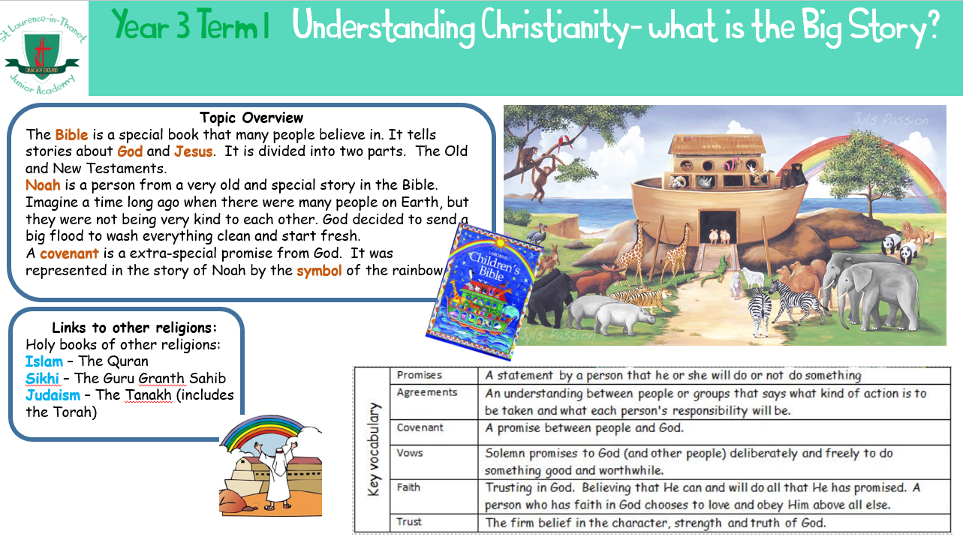

**Year 4**

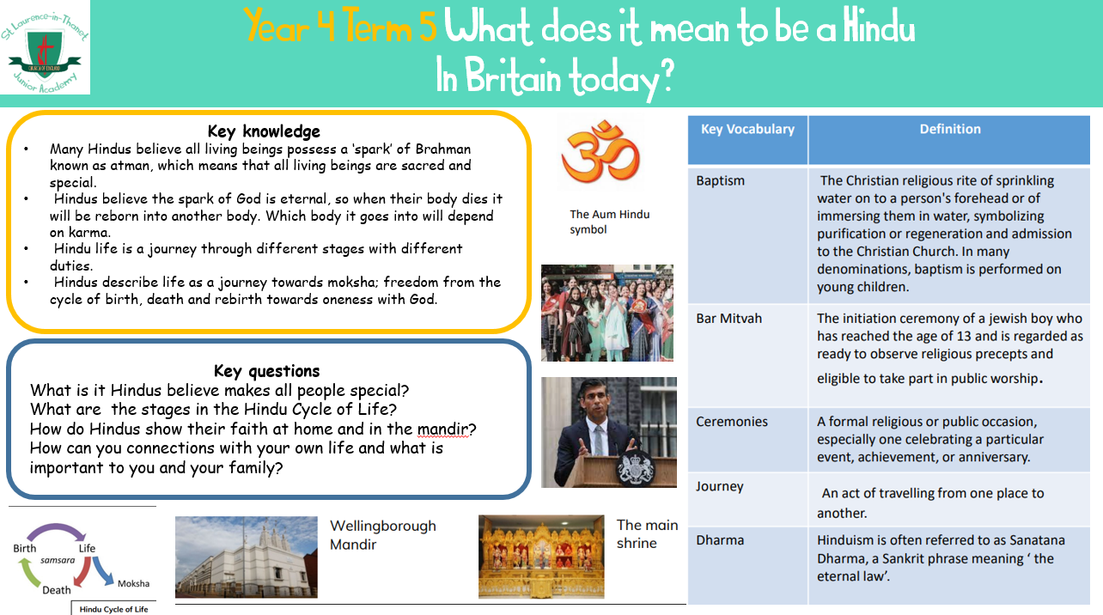

**Year 5**

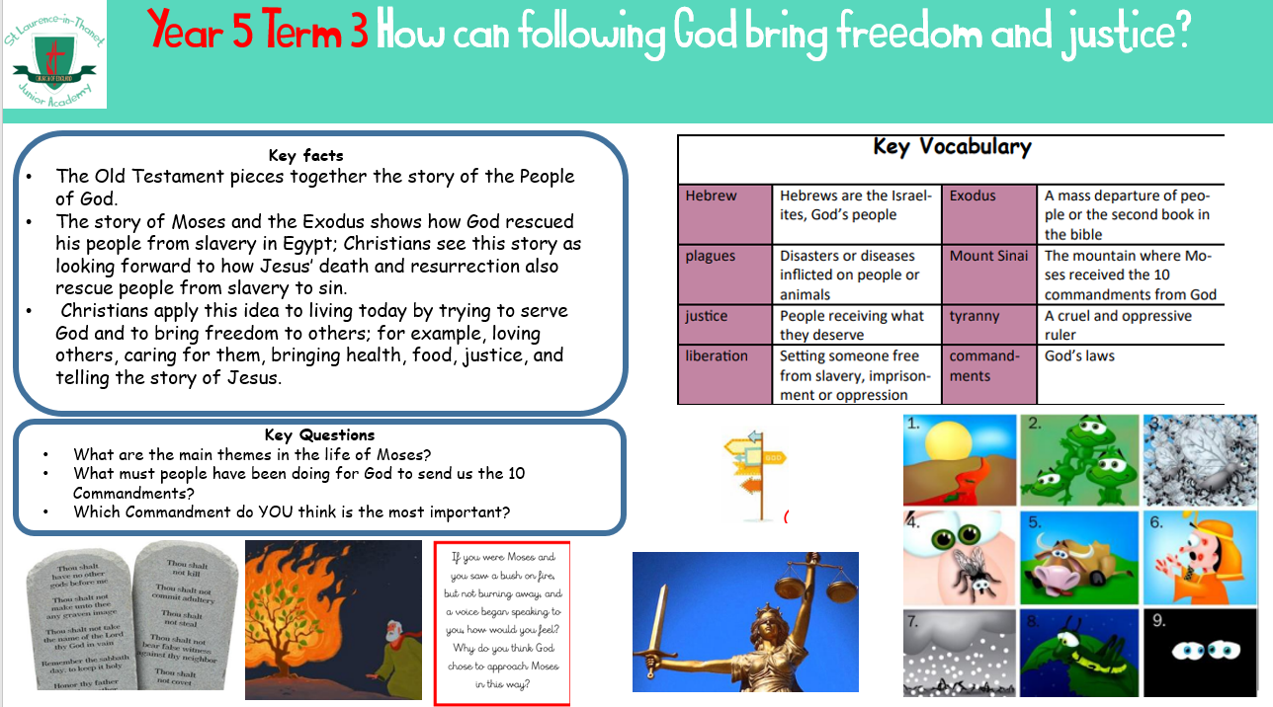

**Year 6**

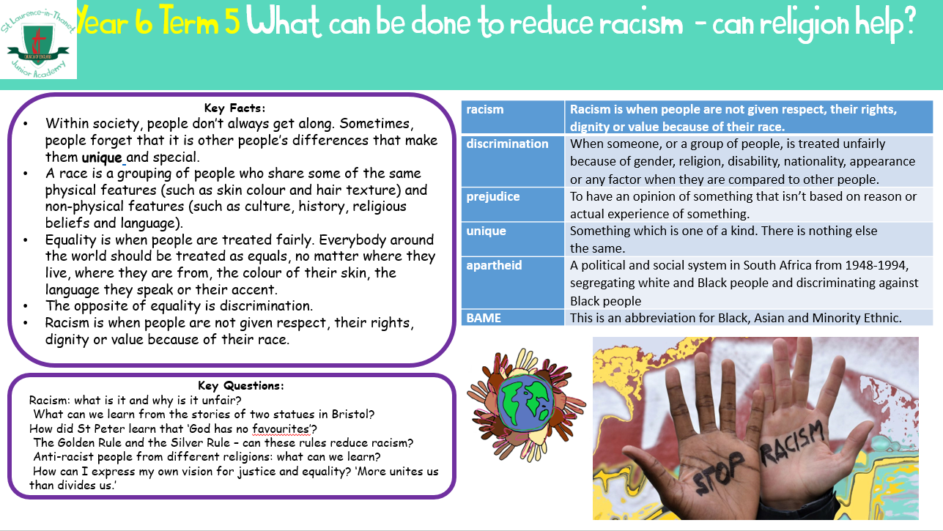

**Displays**

